Name :- Aakash Singh
Email:- aakashsinghRajput8610@gmail.com
Path Traversal (Directory Traversal)

The application is vulnerable to Path Traversal (Directory Traversal) due to improper validation of user-supplied input in the filename parameter.
An attacker can manipulate this parameter to traverse directories and access sensitive files outside the intended web root directory.

Step 1: Intercept Request
While browsing the application, a request was captured using Burp Suite when accessing a product image.
GET /image?filename=product.jpg HTTP/1.1
GET/image?filename=52.jpg HTTP/2

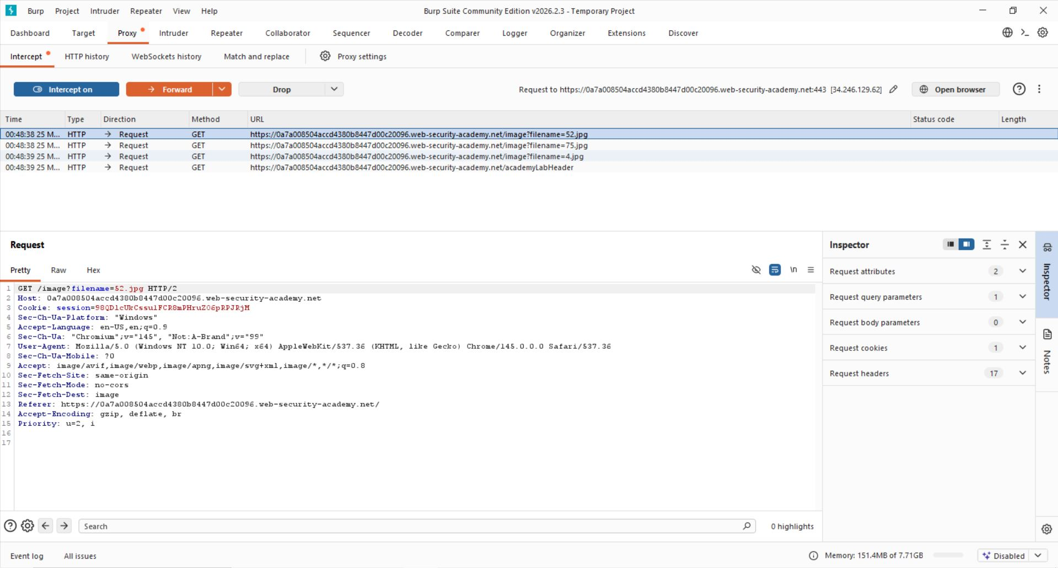

Step 2: Identify Vulnerable Parameter
The filename parameter is used by the application to retrieve files from the server and the filename parameter was modified to include a directory traversal payload
../../../etc/passwd
Response will be :
root:x:0:0:root:/root:/bin/bash
daemon:x:1:1:daemon:/usr/sbin:/usr/sbin/nologin
www-data:x:33:33:www-data:/var/www:/usr/sbin/nologin

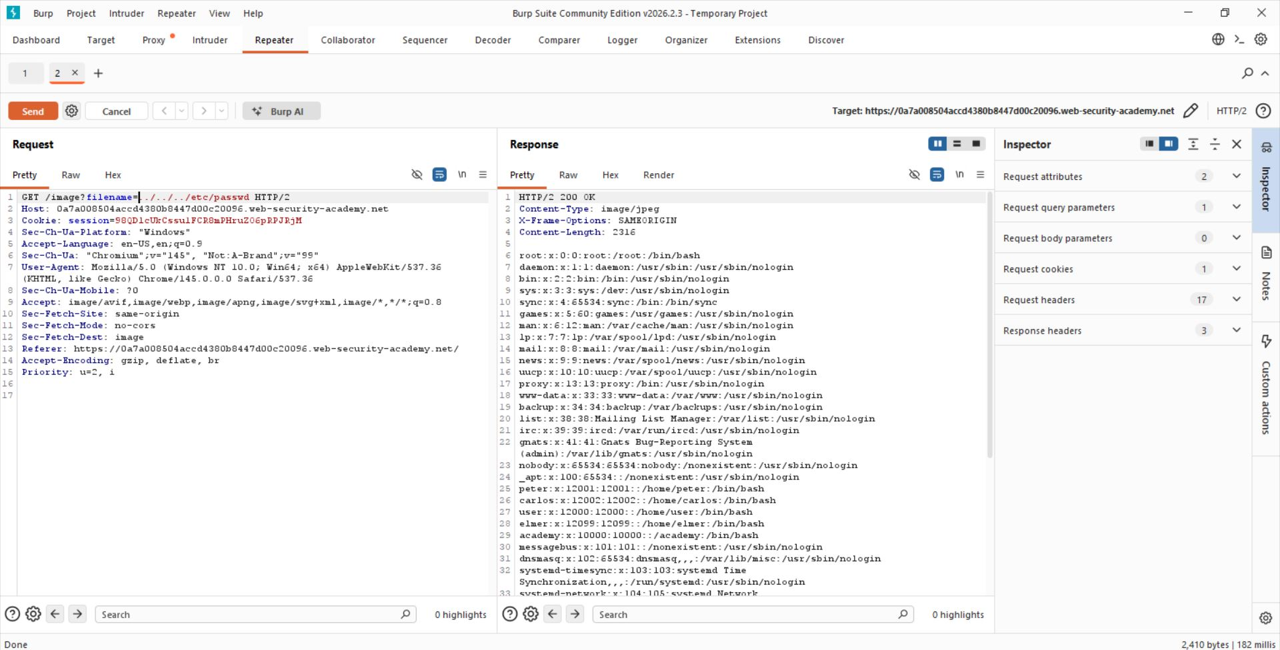

Step 3:- Analyze Response
The server responded with the contents of the /etc/passwd file:

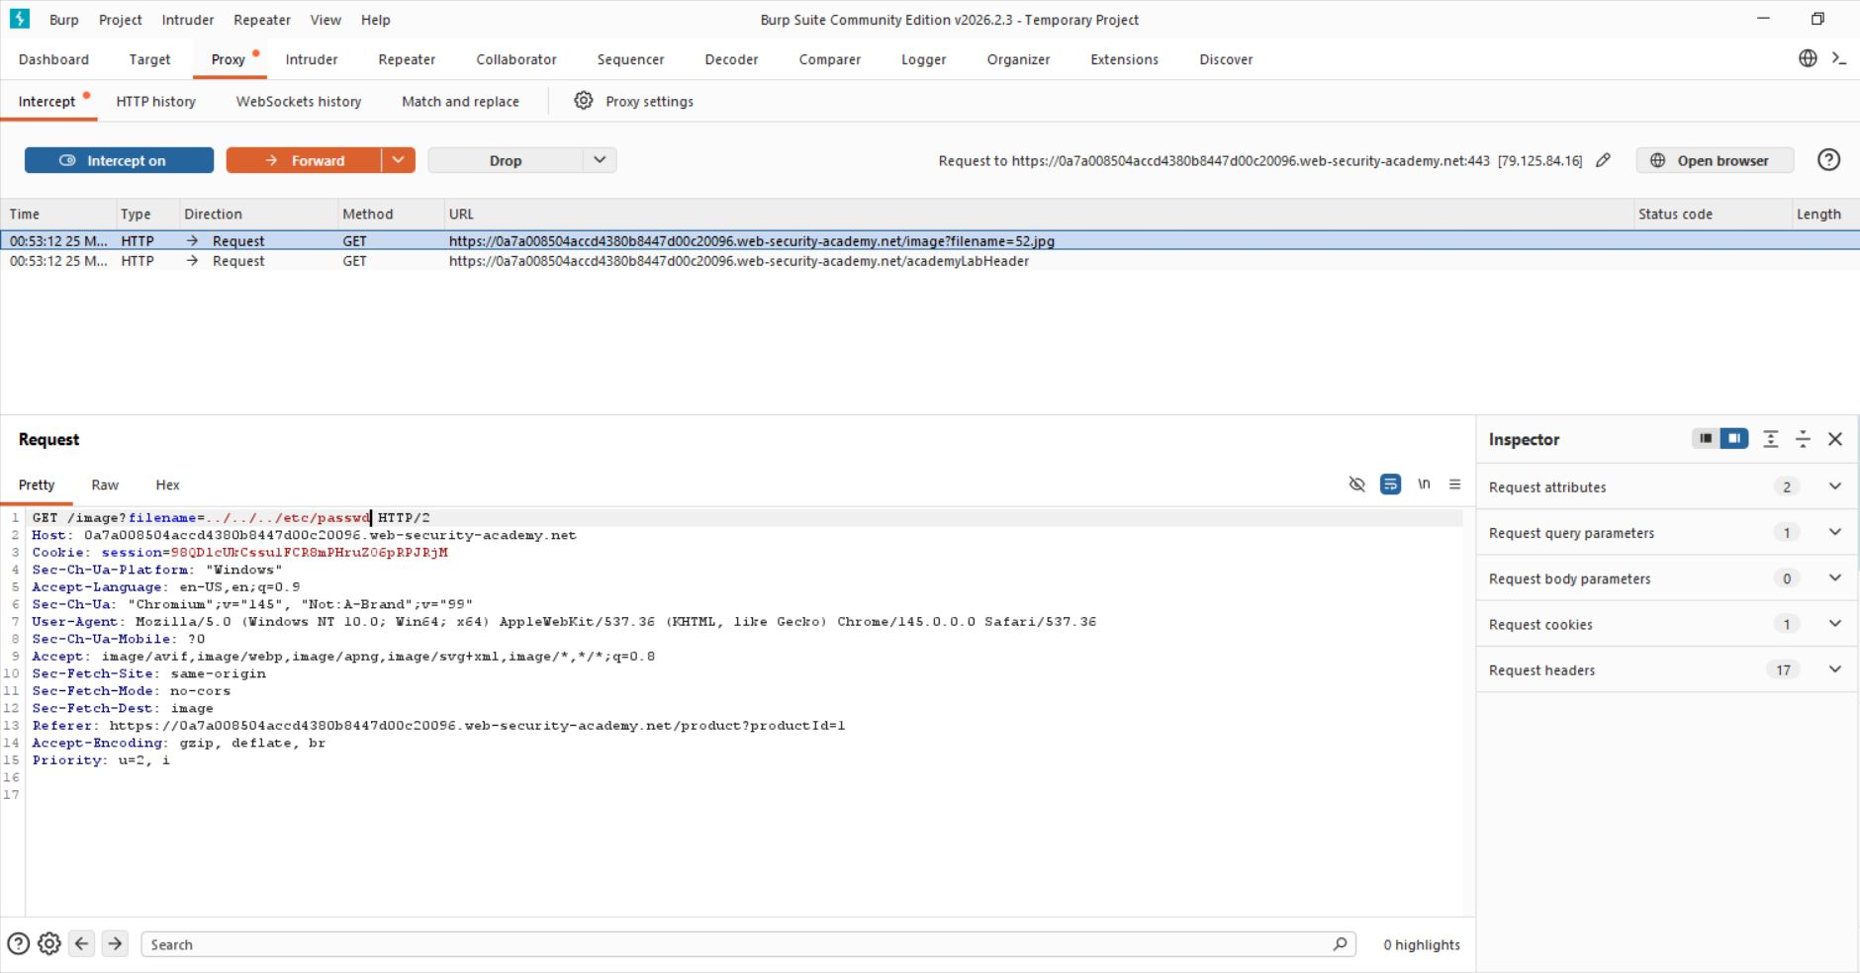
Step 4:- Lab solved successfully.
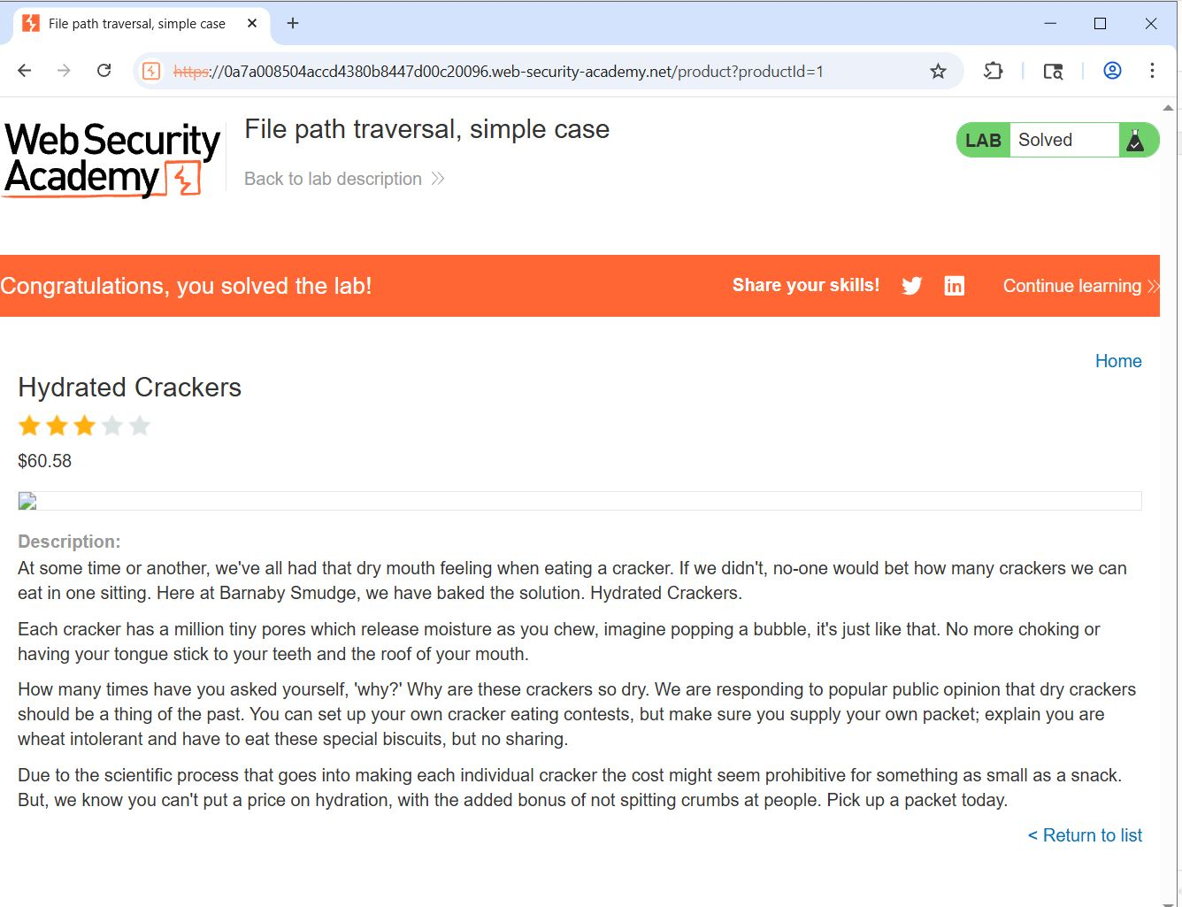

- The application successfully returned sensitive system file contents, confirming that directory traversal is possible.

